WEB DESIGN PROJECT draft content

Home page

Home page *Marketing sections*

_________________________________________________________________

Where do YOU want to go?

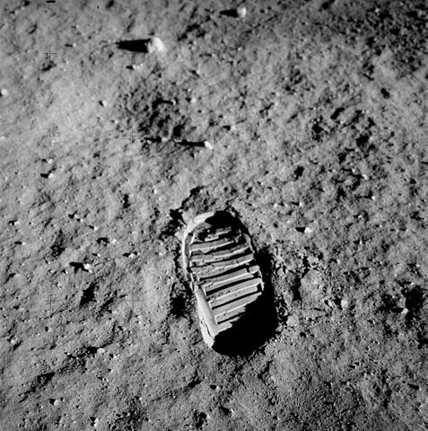

You too can leave your bootprint on the moon.. Or look down on the Earth from 100km above.  
The possibilities of commercial space travel are opening further everyday.  
Don’t set limits on your ambitions.

_________________________________________________________________

**WE can take you there.**

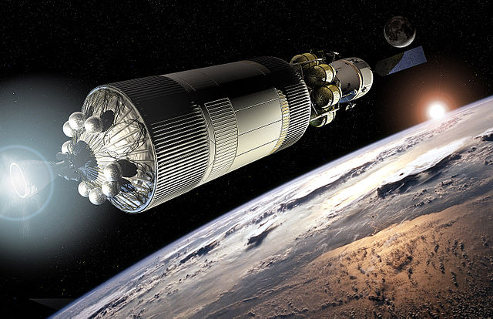

Today, Aurora Ireland have the technology to take on sub-orbital space flight so passengers can blast to the edge of space, experience weightlessness and see the entire world from above.  
Our flightmap over the next ten years will guide us to orbit in outer space, dock with the ISS, explore the moon and other horizons far beyond.

_________________________________________________________________

**Our PARTNERS**

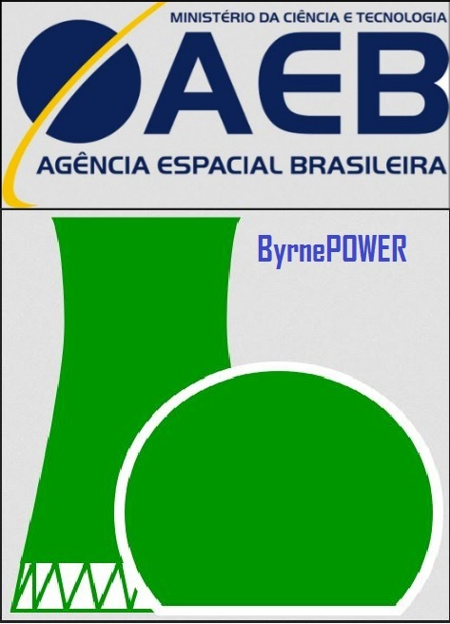

Aurora Ireland is partnering with the Brazilian Space Agency who are facilitating our launch site & with our Irish funding partner ByrnePower led by renowned innovator and philanthropist, Charles M. Byrne.